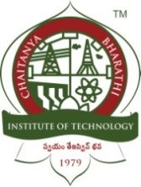**CHAITANYA BHARATHI INSTITUTE OF TECHNOLOGY (A)**

**DEPARTMENT OF COMPUTER SCIENCE AND ENGINEERING**

**Date:** 30th October, 2021

**BE VII Semester CSE-2 Project Part-1 Work Progress Report**

**Target Set for the week:**

* To incorporate information extraction using Natural Language Processing and text-to-speech conversion.
* Analyse and evaluate existing approaches on image pre-processing and text extraction.
* Choose appropriate tech-stack to build our solution.

**Work Status:**

* Analysed various approaches to information extraction from research papers
* Designing the architecture of the solution based on methodology
* Revising tech-stack to move forward with our solution

**Plan for the next week:**

* Finalizing the tech-stack to build our solution.

**Supervisor remarks:**

**Project Supervisor: Roll Numbers:** 1601 18 733 067

Dr. T. Sridevi 1601 18 733 081